TKR College of Engineering & Technology (Autonomous)
Department of Computer Science and Engineering
CSE-A | Batch A11 (CSE, Section A)
AutoSecAI: Autonomous Pull Request Analysis for Security, Vulnerability Detection, and Code Quality using Multi-Agent LLMs
(AutoSecAI)
S.No. | Student name | Roll / hall ticket no.
1 | CHEPURI RISHIVARDHAN | 23K91A0553
2 | BODA SANDEEP | 23K91A0539
3 | DHARAVATH SEETHARAM | 23K91A0562
4 | NARISIMHA REDDY | 24K95A0501
Under the guidance of: P. KISHORE, [DESIGNATION]
CONCLUSION, FUTURE SCOPE AND REFERENCES
This document concludes the project: what was achieved, the key findings, the known limitations, concrete future work, and the numbered list of references.

1 Summary of the Work
This project built AutoSecAI, an analyser that reviews a pull request for security flaws and code-quality problems and explains what it found. A change can be supplied as a diff, two versions of a file, a GitHub link or uploaded files. Seven cooperating agents then parse it, apply abstract-syntax-tree and taint rules, score every changed function with the metric model of the base paper [1], explain each finding with its weakness class, impact and source-to-sink flow, propose a patch that is re-scanned to check that it works, summarise maintainability, and issue a risk score and a verdict. A codebase assistant answers natural-language questions about a repository, and a Model Lab reproduces the base-paper pipeline on Python. The tool is a FastAPI service with a React interface, 17 automated tests and a demonstration account.
On a generated corpus of 6,000 Python functions the metric model (XGBoost) reached an F1 of 0.851 (mean 0.842 +/- 0.006 over five corpora), the rule engine 0.800 and the two together 0.891. The built-in vulnerable pull request was reviewed in a median of 375 ms and blocked with a risk score of 99, and the codebase assistant ranked the expected file first for 8 of 12 questions. These results come from generated data and a small repository; no real labelled pull requests were available.

2 Objectives Achieved
Of the six objectives, the first three were achieved with the limits noted in the results chapter: diff context is extracted on request, not by a webhook; metrics rank the changed functions; and 30 security rules detect injection and validation flaws but not missing object-level authorisation. The objective of deploying LLM agents is met only in part, because the agents are deterministic programs with an optional language-model layer, and related repository code is retrieved by the codebase assistant but not yet fed into the review comments. A consolidated comment is generated and exported, but not posted to GitHub, and precision against manually reviewed pull requests was not evaluated, because no such set was available.

3 Key Findings
1. Two detectors are better than one. On 1,500 held-out functions the rule engine found 88 of 125 vulnerable functions and the model 97; together they found 110 (F1 0.891).
2. Taint-oriented metrics carry the signal. The three metrics added for Python injection (M12, M13, M14) hold 46.4% of the importance; keeping only five metrics gave a validation F1 of 0.566, keeping thirteen 0.786.
3. The headline is the best case. XGBoost reached 0.851 on the stored corpus but 0.842 +/- 0.006 on average over five; Random Forest averaged 0.814 +/- 0.010.
4. Balancing was not shown to help. Recall was identical with and without SMOTE-Tomek and precision fell; because the feature count also differed, the effect of balancing alone remains unmeasured.
5. The model cannot be trusted alone. It gave a probability of 0.006 to a plain SQL-injection function that builds its query in a variable, which the rule SQLI flagged; the type classifier reached only 0.651 accuracy.
6. Fast, but patches need judgement. A review took a median of 375 ms; seven of the 15 security findings of the demonstration received a verified patch and the other eight were left to the developer.
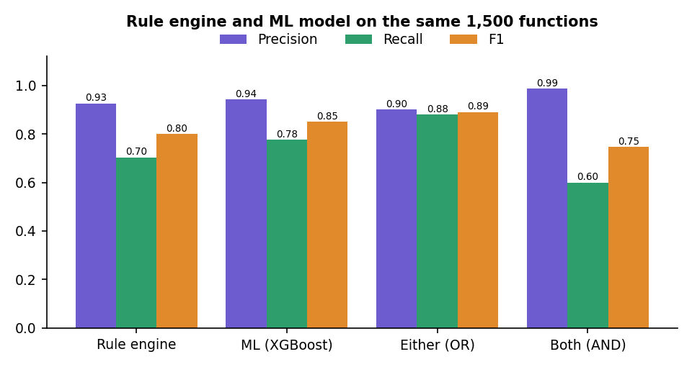
Fig. 1: Rule engine, metric model and their combination on the same held-out functions

4 Practical Applications
- Teams that review pull requests can run the tool before a human reviewer, read the verdict and the findings, and paste the generated comment or upload the SARIF file to code scanning [26].
- Junior developers can index an unfamiliar repository and ask where authentication, routes or the database layer are handled, and read the generated onboarding guide.
- Security trainers can use the demonstration pull request and the explanations, with their CWE [25] and OWASP [24] mapping, to teach the common injection flaws.
- Students of machine learning for software engineering can use the Model Lab to see the effect of feature selection, balancing and model choice on a documented generator.
- Maintainers of small projects without a security team can run the checks locally, because nothing leaves the machine unless the optional language-model layer is switched on.

5 Known Limitations
- The metric model was trained and tested on generated Python functions; its scores are a prioritisation signal and the figures do not transfer to real repositories. The rule-engine figures are optimistic, and no comparison with Bandit, Semgrep or CodeQL was run.
- Deep analysis covers Python only; JavaScript, PHP and Java have regex rules, and missing authorisation checks are not detected. Whole-file fixes exist only for full-file input.
- The optional language-model mode and the real GitHub pull-request fetch were not measured; the job table is in memory and the history is shared by all accounts.
- The retrieval check used 12 questions on one small repository, and no load test or user study was carried out. No numeric comparison with the base paper is possible.

6 Future Scope
The items below follow from the limitations and from the gaps found in the literature survey.

7 Improvements
- Collect a labelled set of real pull requests and measure precision, recall and the false-alarm rate of the whole system on it, next to Bandit, Semgrep and CodeQL.
- Replace the generated corpus with real Python functions labelled from public vulnerability records, retrain, and report both results.
- Re-select the number of metrics for every corpus and run a single-factor experiment for balancing.
- Follow taint across function and module boundaries, add checks for missing authorisation, and add a per-user owner column to the review history.

8 Additional Features
- A GitHub App or webhook that reviews a pull request when it is opened and posts the consolidated comment and the suggested patches back.
- Feeding the codebase assistant's retrieval into the review, so that a finding can mention the callers and related code of the changed function.
- Running the project's own test suite against a patch before it is marked verified.
- More languages with real parsers (JavaScript and TypeScript first), a baseline file for known findings, and a dependency-vulnerability check.

9 Scalability and Deployment
- Move the job table to a queue with a worker process, so that reviews survive a restart and several can run in parallel.
- Replace SQLite with a server database, store the findings in tables, and add user and team ownership with role-based access.
- Serve over HTTPS with a generated signing secret instead of the development default, add rate limiting, and complete a security review of the service itself.
- Package the service as containers with a production build of the interface, measure load and concurrency (not tested here), and run the 17 tests, the smoke test and the 22 browser flows in continuous integration.

10 Further Research
- Compare the metric model with learned detectors of the kind listed in the batch survey, such as hybrid CNN-LSTM [3] and code-language-model approaches [6], on the same real labelled set.
- Study whether a checklist-based evaluation of review comments, as proposed in [2], can be applied to the explanations that AutoSecAI generates, and how a language model should be trained or prompted to meet it.
- Learn the weights of the risk score and the verdict rule from developers' decisions, and calibrate the model probability before combining it with the rule evidence.
- Investigate metrics that capture taint across functions, and whether M12-M14 generalise to other languages.

REFERENCES
[1] B. K. E. Abbasi and A. Shameli-Sendi, "Leveraging key source code metrics for predicting software vulnerabilities with machine learning," IEEE Access, vol. 14, pp. 52610-52625, 2026, doi: 10.1109/ACCESS.2026.3679930.
[2] D. Zhang, S. Zhang, Z. Jin, J. Luo, S. Fu and E. Nallipogu, "Sphinx: Benchmarking and modeling for LLM-driven pull request review," arXiv:2601.04252, Jan. 2026.
[3] "Enhancing software security with CNN-LSTM hybrid model: Vulnerability detection," 2025 (listed in the batch literature survey; not independently retrieved).
[4] "Real-time AI code security auditing: Automated vulnerability detection and remediation through meta-experimental analysis," 2025 (listed in the batch literature survey; not independently retrieved).
[5] "Improving software security: A multi-modal framework for vulnerability detection using code simplification and meta-learning," 2025 (listed in the batch literature survey; not independently retrieved).
[6] "Advancing software security: DcodeBERT for automatic vulnerability detection and repair," 2024 (listed in the batch literature survey; not independently retrieved).
[7] H. Shahriar and M. Zulkernine, "Mitigating program security vulnerabilities: Approaches and challenges," ACM Comput. Surv., vol. 44, no. 3, pp. 1-46, Jun. 2012.
[8] Y. Shin and L. Williams, "Can traditional fault prediction models be used for vulnerability prediction?" Empirical Softw. Eng., vol. 18, no. 1, pp. 25-59, Feb. 2013.
[9] B. Chernis and R. Verma, "Machine learning methods for software vulnerability detection," in Proc. 4th ACM Int. Workshop Secur. Privacy Anal., Mar. 2018, pp. 31-39.
[10] F. Yamaguchi, M. Lottmann and K. Rieck, "Generalized vulnerability extrapolation using abstract syntax trees," in Proc. 28th Annu. Comput. Secur. Appl. Conf., Dec. 2012, pp. 359-368.
[11] R. Russell et al., "Automated vulnerability detection in source code using deep representation learning," in Proc. 17th IEEE Int. Conf. Mach. Learn. Appl. (ICMLA), Dec. 2018, pp. 757-762.
[12] Z. Li, D. Zou, S. Xu, X. Ou, H. Jin, S. Wang, Z. Deng and Y. Zhong, "VulDeePecker: A deep learning-based system for vulnerability detection," arXiv:1801.01681, 2018.
[13] L. Wartschinski, Y. Noller, T. Vogel, T. Kehrer and L. Grunske, "VUDENC: Vulnerability detection with deep learning on a natural codebase for Python," Inf. Softw. Technol., vol. 144, Art. no. 106809, Apr. 2022.
[14] H. Hanif, M. H. N. Md Nasir, M. F. Ab Razak, A. Firdaus and N. B. Anuar, "The rise of software vulnerability: Taxonomy of software vulnerabilities detection and machine learning approaches," J. Netw. Comput. Appl., vol. 179, Art. no. 103009, Apr. 2021.
[15] N. V. Chawla, K. W. Bowyer, L. O. Hall and W. P. Kegelmeyer, "SMOTE: Synthetic minority over-sampling technique," J. Artif. Intell. Res., vol. 16, pp. 321-357, 2002.
[16] I. Tomek, "Two modifications of CNN," IEEE Trans. Syst., Man, Cybern., vol. SMC-6, no. 11, pp. 769-772, Nov. 1976.
[17] G. E. A. P. A. Batista, R. C. Prati and M. C. Monard, "A study of the behavior of several methods for balancing machine learning training data," ACM SIGKDD Explor. Newsl., vol. 6, no. 1, pp. 20-29, 2004.
[18] L. Breiman, "Random forests," Mach. Learn., vol. 45, no. 1, pp. 5-32, 2001.
[19] T. Chen and C. Guestrin, "XGBoost: A scalable tree boosting system," in Proc. 22nd ACM SIGKDD Int. Conf. Knowl. Discovery Data Mining, 2016, pp. 785-794.
[20] F. Pedregosa et al., "Scikit-learn: Machine learning in Python," J. Mach. Learn. Res., vol. 12, pp. 2825-2830, 2011.
[21] T. J. McCabe, "A complexity measure," IEEE Trans. Softw. Eng., vol. SE-2, no. 4, pp. 308-320, Dec. 1976.
[22] G. Salton and C. Buckley, "Term-weighting approaches in automatic text retrieval," Inf. Process. Manage., vol. 24, no. 5, pp. 513-523, 1988.
[23] L. Page, S. Brin, R. Motwani and T. Winograd, "The PageRank citation ranking: Bringing order to the web," Stanford InfoLab, Stanford, CA, USA, Tech. Rep. 1999-66, 1999.
[24] OWASP Foundation, "OWASP Top 10:2021," 2021. [Online]. Available: https://owasp.org/Top10/
[25] MITRE Corporation, "Common Weakness Enumeration (CWE)." [Online]. Available: https://cwe.mitre.org/
[26] OASIS, "Static Analysis Results Interchange Format (SARIF) Version 2.1.0," OASIS Standard, Mar. 2020.
[27] M. Jones, J. Bradley and N. Sakimura, "JSON Web Token (JWT)," IETF RFC 7519, May 2015.
[28] N. Provos and D. Mazieres, "A future-adaptable password scheme," in Proc. USENIX Annu. Tech. Conf., 1999, pp. 81-91.

